CS 240

Unit Testing

Rachel Gilligan

11/20/18

The portion of the project I have been working on is the Graphical User Interface (GUI).

The first frame to be displayed is the frame which will ultimately lead to the Sign-in and Register frames. Since there has been nothing liked to the ‘Sign Me Up!’ button, there should be nothing occurring when that button is selected. This expected behavior is occurring.

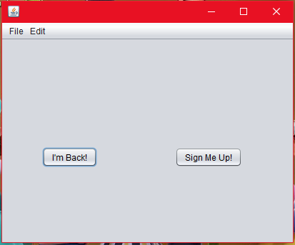

Associated code:

Program.java

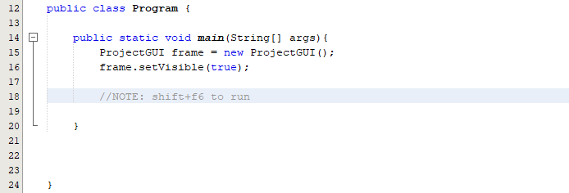

Clicking the button ‘I’m Back’ should bring up a new window which will be a sign-in window. This button currently leads to a ‘Sample Frame’ which will ultimately become this sign-in window. So far, the expected behavior is occurring.

 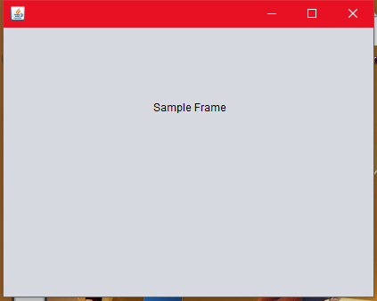

Associated Code:

ProjectGUI.java

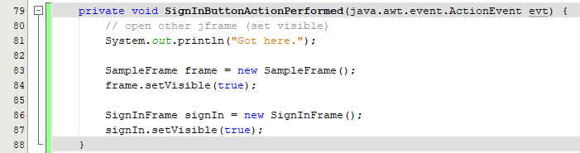

SampleFrame.java

